Healthy and Unhealthy Relationships

Everyone is entitled to:
- Dignity and respect
- Feel free to be your true self - inside and outside the relationship
- Equality between partners, making decisions together, living by the same standards

Unhealthy Relationships
- You may feel unsafe in your relationship
- If someone is hurting or controlling you, you may be a victim of domestic violence (DV)
- DV is when one person hurts another person in a relationship
- It can harm your health – now and in the future
- It can also harm your child’s emotional and physical health and safety

Types of Domestic Violence
- Verbal: Threatening to hurt you or your child
- Psychological: Calling you names or putting you down
- Physical: Slapping, choking or kicking you
- Sexual: Forcing you to have sex
- Economic: Not letting you work or go to school

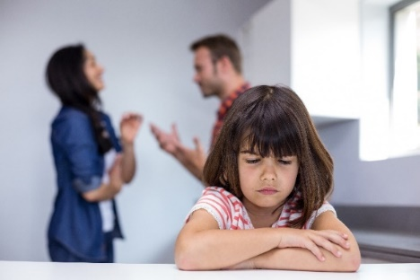
Victims of Domestic Violence May Feel
- Many different things - it affects people in lots of ways
- Trapped or scared to leave or reach out for help
- Afraid, ashamed or alone

Create a Safety Plan
- A plan to keep your family safe – while at home, when planning to leave and after leaving
- Helps in a crisis when it’s hard to think calmly
- May include: a plan for how and to where you can safely escape, bag with important belongings, code word children know if needing to leave quickly, children know how to call 911 or a trusted contact
- Advocates from the National Domestic Violence Helpline can create a safety plan

Helpful Resources
National Domestic Violence Hotline | www.thehotline.org
- Advocates available 24/7 for free, confidential help, information, crisis intervention, safety planning and connecting you to help nearby
- Help in over 200 languages
- Call 1-800-799-SAFE (7233), 1-800-787-3224 (TTY) or 1-855-812-1001 (video phone - if deaf)
- Visit the website and choose “Chat Now” for English 24/7. “Chat in Spanish” from 12 – 6pm CDT
- Your computer use can be monitored; if you’re afraid this may be happening, call a hotline
- Pamphlets with information on DV should be hidden in a safe place, like in a shoe or under clothes

You don’t deserve to be treated this way!
Make your home a safe place for love, not violence.
If you’d like help, please tell your child’s doctor or nurse.

