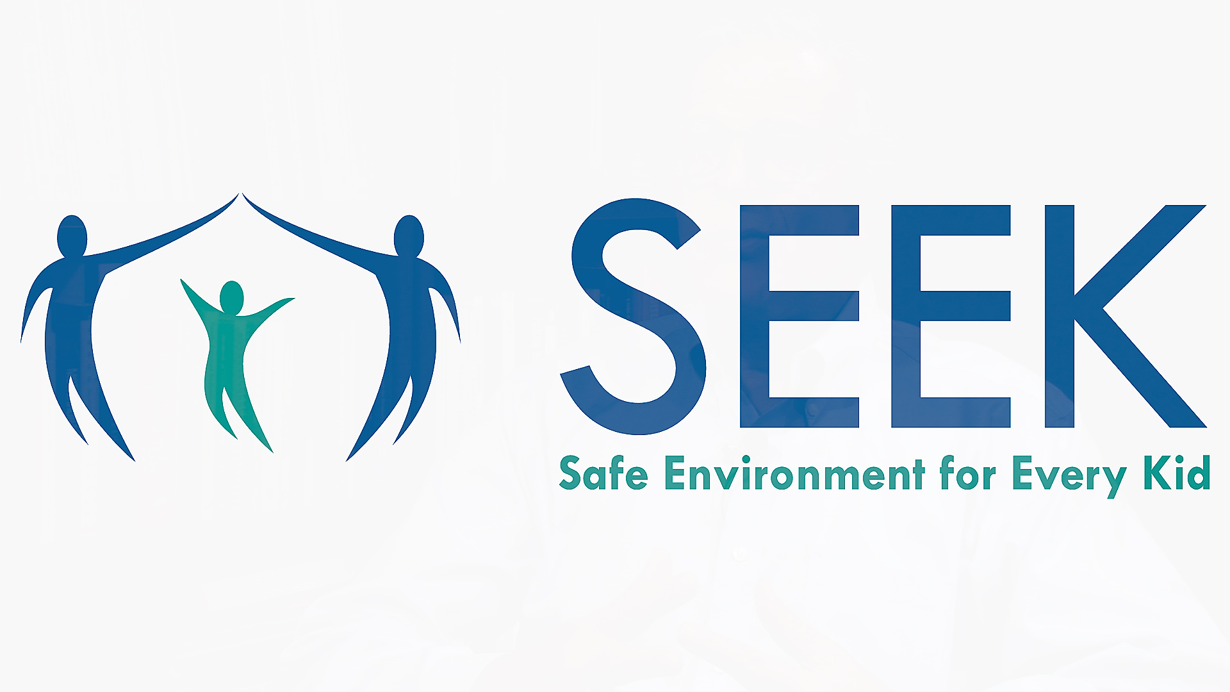

SEEK
University of Maryland School of Medicine
Department of Pediatrics
520 West Lombard Street
Baltimore, MD 21201

Who we are
Don’t be shy! Let them know how great you are. This is the back cover of your booklet, so it’s one of the first and last things the recipient sees.
It’s a great place for your ‘elevator pitch.’ If you only had a few seconds to pitch your products or services to someone, what would you say?
- Consider including a couple of key takeaways on this back cover…
- Just remember that this is marketing—if you want to grab their attention, keep it brief, friendly, and readable.

Contact Us
If you have a physical location, provide brief directional information, such as highways or landmarks:
[Street Address]
[City, ST ZIP Code]
Phone: [Telephone]
Email: [Email address]
Web: [Web address]

[Company Name]
[Street Address]
[City, ST ZIP Code]

© 2021, The SEEK Project
Practice logo and/or name
Address 1
Address 2
Phone number
Website

Safe Environment for Every Kid (SEEK)
Welcome to the Safe Environment for Every Kid (SEEK)  Dear Parent or Caregiver:  Being a parent is not always easy. We want to help families have a safe environment for children. So, we’re asking everyone about issues that affect many families. If there’s a problem, we’ll try to help.  About SEEK  SEEK aims to strengthen families, support parents and parenting, and promote children's health, wellbeing, development and safety.  SEEK was developed to take advantage of the excellent opportunities in primary healthcare to learn about a child’s family environment and to help when needed. We know that what happens in a family is so important to children’s healthy growth and futures.  SEEK helps identify and address common problems – parental depression, substance use, severe stress, domestic violence, food insecurity, and discipline challenges. It also builds upon parents’ and families’ interests and strengths.  What is the SEEK PQ-R?  The SEEK PQ-R is a questionnaire to identify possible problems. You’re invited to answer questions about your child being seen for a checkup. This is voluntary. You don’t have to answer any question you prefer not to. The information is kept confidential, unless we're worried about your child's safety. |  |  | What happens after you complete the SEEK PQ-R?  Your child’s doctor or nurse or other staff in the practice will discuss possible problems with you. Together, you’ll decide whether further assessment or help may be needed.  What can your child’s doctor or nurse help with?  Your child’s doctor or nurse can help you with possible problems. They can connect you with someone else in the practice or in the community for help.  What to do if you have questions about SEEK?  Please discuss any questions or concerns with your child’s doctor or nurse.  To learn more about SEEK, use the QR below to view a short video!  If possible, point your phone camera at the QR code below and you’ll be directed to the SEEK video.  