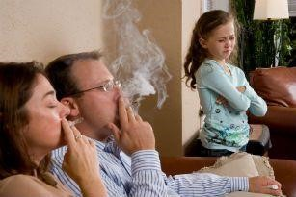
Tobacco Use
Types of smoke and the risks:
First-hand smoke: Smoke directly inhaled by the smoker
- Up to 4 times higher risk of stroke or heart disease
- 15 to 30 times higher risk for lung cancer

Second-hand smoke: Smoke inhaled involuntarily from the use of others
- Cancer-causing toxins can be found in the blood of non-smokers, even after little exposure to second-hand smoke
- Children exposed to second-hand smoke are at a higher risk of upper respiratory and ear infections

Third-hand smoke: Smoke deposits left on clothing, skin and surfaces
- The young brain may be hurt by even very low levels of toxins
- Children are at risk because they often put their hands in their mouth after touching affected areas
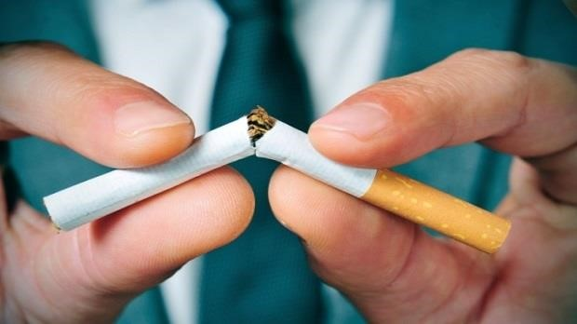

Helpful Tips:
- Decide on something different to do when you want to smoke, like chewing gum
- Make a pledge to quit, and tell your family
- Talk with your doctor about a plan to quit
- Track progress, like making a “days smoke-free” calendar
- Make a list of triggers and a plan for staying away from them
- Sign up for reminder texts about why you want to quit at: www.smokefree.gov/tools-tips/text-programs

Don’t let tobacco hurt your family. Any smoke has risks.
To quit smoking, please talk to your or your child’s doctor or nurse.

Helpful Resources
Smoking Quitline
- Call 1-877-44U-QUIT (1-877-448-7848) for help in English and Spanish, Monday – Friday, 9am to 9pm EST

Smokefree | www.smokefree.gov
- Tools, tips and resources to quit smoking
- Call 1-800-QUIT-NOW (1-800-784-8669) to connect with your state’s quitline
- Visit the website and choose “Live Help” for English and Spanish, Monday – Friday, 9am to 9pm EST
- Visit www.espanol.smokefree.gov for help in Spanish

Freedom from Smoking | www.freedomfromsmoking.org
- Tools, tips and resources to quit smoking
- Call 1-800-LUNGUSA (1-800-586-4872) for help in English and Spanish

