Do You Feel Safe?
Is anyone hurting or controlling you?
If so, you may be a victim of domestic violence.
Domestic violence is when one person hurts another person in a relationship.
It can cause you health problems – now and in the future.
It can also harm your child’s emotional and physical health.

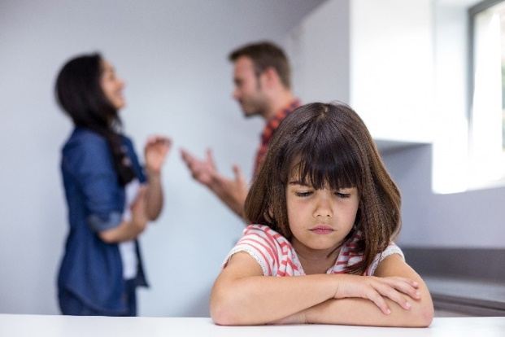
Types of domestic violence:
- Verbal: Threatening to hurt you or your child
- Psychological: Calling you names or putting you down
- Physical: Slapping, choking or kicking you
- Sexual: Forcing you to have sex
- Economic: Not letting you work or go to school

Victims of domestic violence may feel:
- Many different things - it affects people in lots of ways
- Trapped or scared to leave or reach out for help
- Afraid, ashamed or alone

Create a Safety Plan:
- Individualized plan to keep your family safe when you’re in a relationship, planning to leave or after you leave
- Helpful in a crisis when it’s hard to think the same as when you’re calm
- May include some of the following information, like a plan for how and where you can safely escape, bag prepared with important belongings, code word children know if they need to leave in an emergency, children know how to call 911 or a trusted contact
- Advocates from the National Domestic Violence Helpline can plan with anyone who is concerned about their own safety or safety of someone else

You don’t deserve to be treated this way!
Make your family a safe place for love, not violence.
If you’d like help, please tell your child’s doctor or nurse.

Helpful Resources
National Domestic Violence Hotline | www.thehotline.org
- Advocates available 24/7 for free, confidential help, information, crisis
intervention, safety planning and connecting you to help nearby
- Help in over 200 languages
- Call 1-800-799-SAFE (7233), 1-800-787-3224 (TTY) or 1-855-812-1001 (video phone -
if deaf)
- Visit the website and choose “Chat Now” for English 24/7. “Chat in Spanish” available daily from 12pm to 6pm CDT
- For your safety, computer use can be monitored and is impossible to completely hide so
if you’re afraid your usage might be monitored, call the hotline
- Pamphlets with information on domestic violence should be hidden, like in a shoe, under clothes in a closet or other safe location

