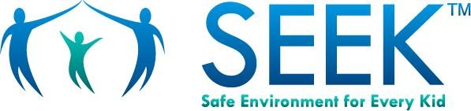
Food Assistance

It’s scary when there’s not enough food for your family.
Getting HEALTHY food is important for children’s growing bodies and minds.

Helpful Resources
Supplemental Nutrition Assistance Program (SNAP) | www.fns.usda.gov/snap
- SNAP (food stamps) puts healthy food on the table for many families each month
- Visit the website or call 1-800-221-5689 for info in your state

Women, Infants, and Children (WIC) | www.fns.usda.gov/wic
WIC helps women and children, up to age 5, with free:
- Healthy foods
- Good advice on healthy eating
- Referrals to other health, welfare and social services

Child Nutrition Programs | www.fns.usda.gov/cn
- To learn about and enroll in free or reduced rate school lunches and breakfasts, talk to your child’s school guidance counselor
- Visit the website to find food programs nearby

USDA National Hunger Hotline
- For info on how your family can get food, call 1-866-3-HUNGRY for English or 1-877-8-HAMBRE for Spanish

If you need help finding food, please talk to your child’s doctor or nurse.

Emergency Food Assistance | www.211.org
- 24/7, confidential, free help in 180 different languages
- For emergency food nearby, call 211 or visit the website
- Additional information on housing, employment, health care and counseling

Feeding America | www.feedingamerica.org
- Visit the website to find free emergency food nearby
- Visit www.feedingamerica.org/en-espanol for help in Spanish

Try to give your children HEALTHY food choices.
With planning and help, you can give your family the food they need.

