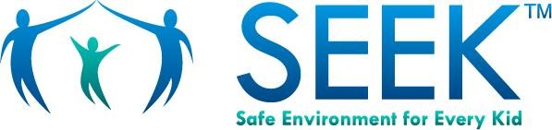
Drugs and Alcohol
Do you or someone you know have a problem with drugs or alcohol?
Lots of people have problems with drugs and alcohol.
Sometimes they can’t see they have a problem.
Drug and alcohol abuse hurts people and their families.

Signs of abuse are when someone:
- Wants to drink or use drugs most days
- Feels sick if they do not have a drink or a drug
- Misses work or school
- Has big mood swings and acts like a different person
- Often forgets things
- Has trouble eating or sleeping

People who abuse drugs or alcohol need help:
- They are hurting themselves and perhaps others
- They might feel sad and lonely or overwhelmed

If you use drugs or drink alcohol a lot, you risk:
- Harming your children
- Relationship problems
- Overdosing
- Dependence
- Poor health
- Accidents
- Legal problems

There is help for drug and alcohol abuse!
If you’d like help, please talk to your child’s doctor or nurse.

Helpful Resources
National Helpline | www.findtreatment.gov
- Call 1-800-662-HELP (4357) for 24/7, free and confidential information on treatment and recovery services - in English and Spanish - for anyone with a drug problem
- Visit the website to find treatment near you
- If you don’t have insurance or are low-income, they’ll help you find:
- Free or low-cost treatment near you
- Places that charge a sliding fee, or accept Medicare or Medicaid

If you do have health insurance, contact your insurer to find help

Alcoholics Anonymous (AA) and Narcotics Anonymous (NA)
- Fellowships of men and women who share their experience, strengths and hopes, to recover from alcoholism and drug addiction
- Free
- To find a group near you, visit www.aa.org or www.na.org

